APPLICANT/CANDIDATE RESUME

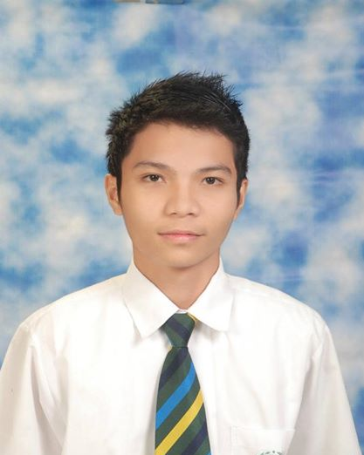
CONTACT INFORMATION
Name: Alec Job A. Melchor
Address: Lower Busay Heights NHA, Cebu City
Telephone number: 2358324
Email address: malecjob@gmail.com

PERSONAL INFORMATION
Date of Birth: April 28, 1995
Age: 21
Citizenship/Nationality: Filipino
Gender: Male
Marital Status: Single
Language proficiency: English, Filipino, Cebuano
Computer PMS and Software skills: Web Development

EDUCATIONAL BACKGROUND (state year achieved)
- Education Level

2012-Present
University of San Carlos – Talamban Campus
Tertiary

2008-2012
University of San Carlos – North Campus
Secondary

2002-2008
University of San Carlos – North Campus
Elementary

STRENGTHS/TRAITS & SKILLS (see below examples)
- Optimistic
- Independent
- Willing to learn new things
- Understandable
- Ethical

TECHNICAL SKILLS
- Knowledgeable in Multimedia like Adobe Photoshop, After Effects and Premiere Pro.
- Knowledgeable in basic troubleshooting and networking configurations.
- Knowledgeable in C and Java programming language.

CAREER OBJECTIVES

To develop and explore more to enhance my skills and knowledge in this field.

WORK EXPERIENCE

April – June 2016 Cloud Employee (Roccatech PHP)
OJT Student

References

- Jeane Villacrucis
Bill Processor
Accenture Cebu City, Philippines
09233023099

- Mr. Cañabano
Teacher
University of San Carlos – North Campus
0932 880 7129

